**Passage 1: Cheating death (Unit 6)**

1. Have you ever ***pictured yourself growing older***? Unwilling to ***disclose your age*** after about 40; afraid to be referred to as "***over the hill," "an old codger (有怪癖的老人)***," and many other similar phrases — in a word, having a sense of shame about the normal human experience of aging. Well, this may not be necessary ***in the near future***.

picture

|  |  |
| --- | --- |
| A.IMAGINE 想象  ~ sb (as sth) to imagine sb/sth; to create an image of sb/sth in your mind 想象；设想；忆起  (什么搭配？) | I can still picture the house I grew up in.  We found it hard to picture him as the father of teenage sons.  When he did not come home she pictured him lying dead on the roadside somewhere.  I tried to picture what it would be like to live alone. |
| B.DESCRIBE 描绘  [动词 + 名词短语][常用被动态] ~ sb/sth as sth to describe or present sb/sth in a particular way 描述；描写 | Before the trial Liz had been pictured as a frail woman dominated by her husband. |

He pictured her with long black braided hair.

I never would have pictured this as her home.

造句：

1. Imagine a world in which ***getting fitted with a new heart,*** liver or other organs, all grown from your own body cells, was as ***commonplace*** as ***knee replacements*** are now. Or one in which you celebrated your 94th birthday by ***running a marathon*** with your school friends. Imagine, in other words, a world in which ***aging had been abolished***.

Imagine you are old ....

1. PUT STH SOMEWHERE 安置

|  |  |
| --- | --- |
| [动词 + 名词短语] to put or fix sth somewhere 安置，安装（在某处） | They fitted a smoke alarm to the ceiling.    The rooms were all fitted with smoke alarms. |
| [+ 副词或介词短语] to put or join sth in the right place 合上；盖上；组合；组装 | The glass fits on top of the jug to form a lid. 这个玻璃杯放在大罐口上恰好当个盖子。  How do these two parts fit together ? 这两部分如何拼在一起呢？  We fitted together the pieces of the puzzle. |

1. That world is ***not yet on offer*** but something like it ***might be on the way***. The process of aging is something doctors and scientists are increasingly studying. ***Suspending it is not yet on the cards.*** But slowing it probably is. ***Average lifespans*** have risen a lot over the past century, but that was thanks to better food, housing, public health and some medicines. ***The new increase would be brought about by specific anti-aging drugs,*** some of which may already exist.

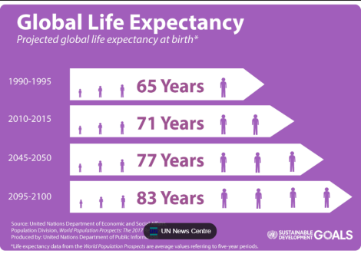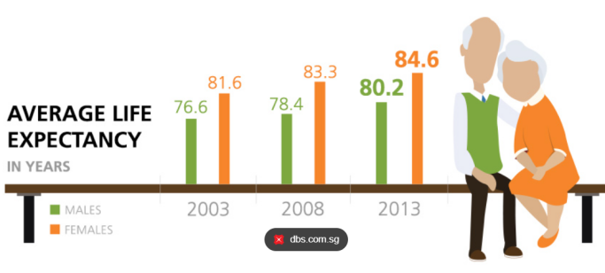

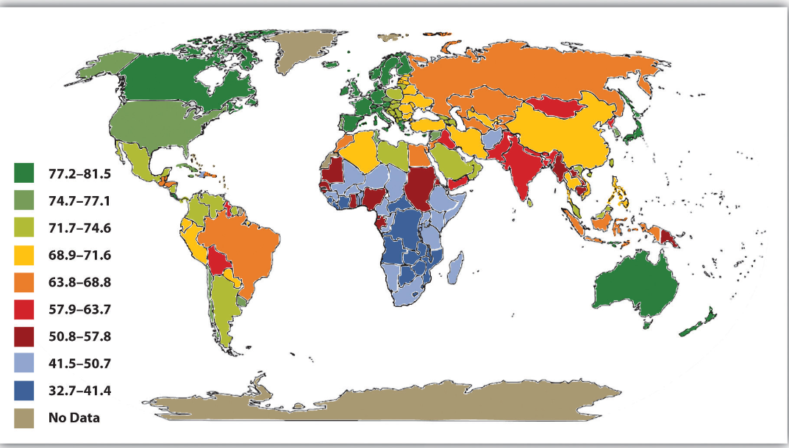

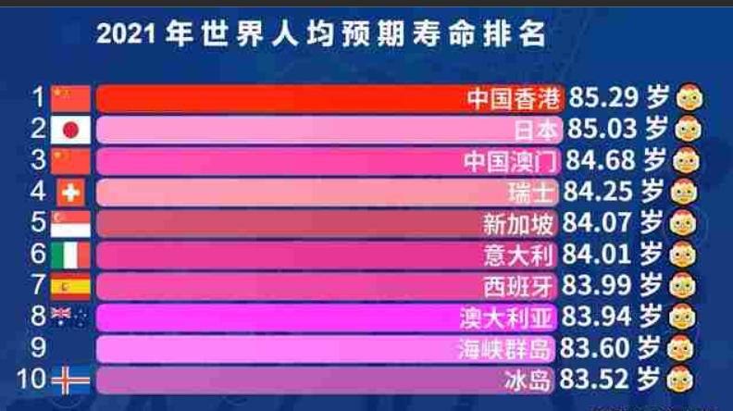

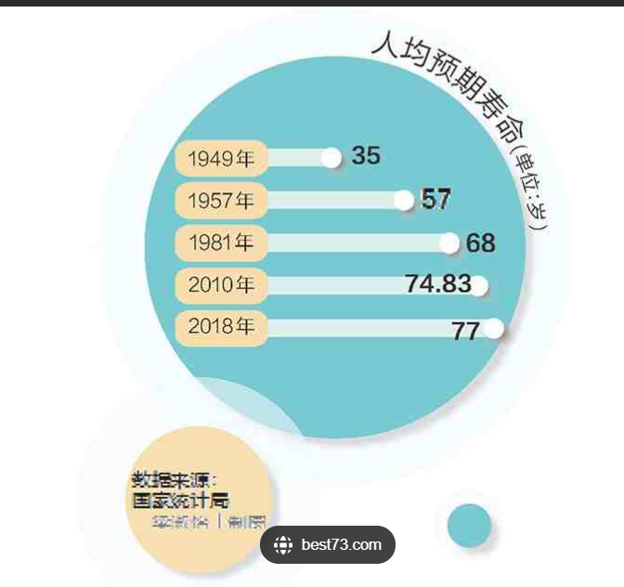

1. This, optimists claim, will ***extend life*** for many people to today's ***ceiling*** of 120 or so. But it may be just the beginning. In the next ***phase*** not just average lifespans but maximum lifespans will rise. If ***a body part wears out,*** it will be repaired or ***replaced altogether***. ***DNA will be optimized for long life.*** Add in ***anti-aging drugs***, and it will be common for people to live over 100.

price ceilings

an informal agreement to put a ceiling on salaries..

[5] ***To this end,*** many hopeful repairmen are now ***setting up shop.*** Some of them want to ***upgrade worn-out tissues using stem cells.*** The business of ***growing organs from scratch*** is also ***proceeding***. At the moment, these organs are small, imperfect and used mainly for drug testing. But that will surely change. ***Longevity is known to run in families, which suggests that particular varieties of genes prolong life***. Some are investigating this, with the thought that modern ***gene-editing techniques*** might one day be used to make crucial, ***life-extending*** changes to the DNA of those who need them.

[6] ***From an individual's viewpoint, this all sounds very desirable***. For society as a whole, though, it will have profound effects. Most of them will be good, but not all.

***desirable***

(formal) ~ (that)… | ~ (for sb) (to do sth) that you would like to have or do; worth having or doing 想望的；可取的；值得拥有的；值得做的 （反义：undesirable)

(British English)It is desirable that interest rates should be reduced.

(North Amercian English)It is desirable that interest rates be reduced.

highly desirable 非常可取

The house has many desirable features. 许多吸引人的特点

It is no longer desirable for adult children to live with their parents.不再想

She chatted for a few minutes about the qualities she considered desirable in a secretary.一个秘书应有的品质

Such measures are desirable, if not essential. 这些措施即使不是必要，也是可取的。

造句：______________

1. ***One concern is that*** long life will make ***existing social and economic problems*** worse. ***The most immediate challenge will be access to anti-aging treatment.*** If longer life is expensive, who gets it first? Already, income is one of the best ***predictors of lifespan***. ***Widening the gap with treatments inaccessible to the poor might deepen divisions.***

What are the predictors of lifespan?

[8] Will older workers ***be discriminated against,*** or ***will numbers give them the whip hand over the young?*** Will older people ***hold onto their jobs for longer,*** or will they grow bored, quit and do something else entirely? And will all those old people ***keep youthfully vigorous mentally as well as physically*** or instead make society more conservative (because old people tend to be)?

[9] A reason for hoping that the elderly would ***turn out less hidebound*** is that life itself would be more ***a series of new beginnings*** than one single story. ***Middle-aged crises*** might ***be not so much about recapturing lost youth as wondering how to make the most of the next half-century.***

not so much … as… **与其说是……不如说是…… (难点)**

**e.g. It was not so much the horrible film as the girls’ screams which made it scary.**

**It wasn’t so much the clothes as the man himself who impressed us immediately.**

* **Adolescents, boys and girls, form deeply sentimental attachments, walk and talk together –** *not so much to* **polish their wits** *as to* **share their hopes and fears and dreams**
* **It is not so much the years that one lives as the quality of life that is important.**

[10] Retirement would become a more distant option for most, since ***pension pots would have to be enormous to support their extended lifespans***. To this end, ***the portfolio career would become the rule*** and education would have to ***change accordingly***. People might go back to school in their 50s to learn how to do something completely different. ***The physical laborer*** would surely need a rest. The accountant might become a doctor. The lawyer, a charity worker. Perhaps some will ***take long breaks*** between careers and ***party wildly***, ***in the knowledge that medicine can offer them running repairs.***

[11] ***Such speculation is fun, and mostly optimistic.*** ***The promise of a longer life, well lived, would round a person out.*** But this vision of the future depends on one thing — that a long existence is also a healthy one. ***Humanity must avoid the trap fallen into by Tithonus,*** a character in Greek legend, who ***was granted eternal life*** but not eternal youth. ***Eventually, he withered into a cicada.***

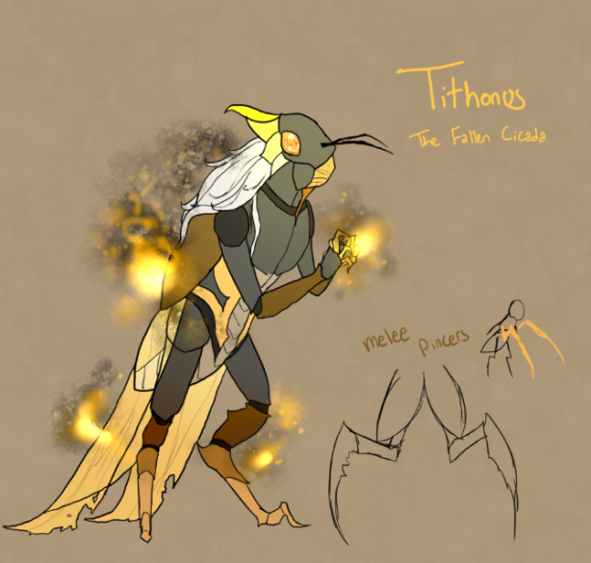

[12] ***This trap should be cautioned against.*** Living longer is terrific, but ***living pain-free and independently*** is what most people really want. Many health problems, specifically those connected to the heart and the bones, ***are guarded against in youth, but crammed into old age***. This must be taken into consideration if a long and healthy life is to ***become routine***. Moreover, even a healthy brain may ***age badly***. ***An organ evolved to keep 70 or 80 years of memories may be unable to cope when asked to store 150 years' worth.***

[13] Yet ***biological understanding is advancing quickly***. ***Greater longevity is within reach*** — even if actual immortality may not be as close (or as interesting) as some fantasists would like to believe. Be sure to ***draw up a very long bucket list***.

How long is your bucket list?